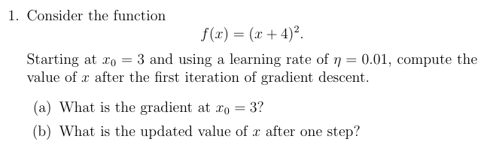
We are given:
Initial value:
$$x_{0}=3$$
Learning rate:
$$η=0.01$$
Gradient descent update rule:
$$x_{\text{new}}=x_{\text{old}}-η f^{'}(x)$$

(a) Find the gradient at $x_{0}=3$
First differentiate the function:
$$f(x)=(x+4)^{2}$$
Using the chain rule:
$$f^{'}(x)=2(x+4)$$
Now substitute $x=3$:
$$f^{'}(3)=2(3+4) \\ f^{'}(3)=2(7)=14$$
✅ Gradient at $x_{0}=3$:
$$\boxed{14}$$

(b) Update $x$after one gradient descent step
Use:
$$x_{1}=x_{0}-ηf^{'}(x_{0})$$
Substitute values:
$$x_{1}=3-(0.01)(14) \\ x_{1}=3-0.14 \\ x_{1}=2.86$$
✅ Updated value after first iteration:
$$\boxed{x_{1}=2.86}$$
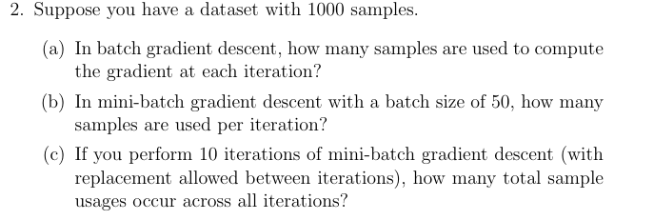

Dataset size:
$$1000\text{ samples}$$

(a) Batch Gradient Descent
In batch gradient descent, the gradient is computed using the entire dataset in every iteration.
So, number of samples used per iteration:
$$\boxed{1000}$$

(b) Mini-Batch Gradient Descent
Mini-batch size is given as:
$$50$$
This means each iteration uses only 50 samples.
So, samples used per iteration:
$$\boxed{50}$$

(c) Total sample usages in 10 iterations
Each iteration uses:
$$50\text{ samples}$$
Number of iterations:
$$10$$
Total sample usages:
$$50×10=500$$
✅ Answer:
$$\boxed{500}$$
Note
“With replacement allowed” means the same sample can appear again in different iterations, so we count total usages, not unique samples.

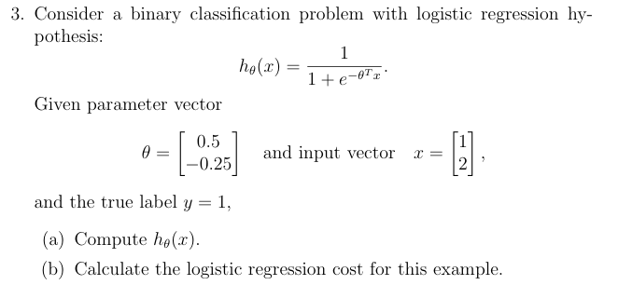

We are given:
$$h_{θ}(x)=\frac{1}{1+e^{-θ^{T}x}}$$
Parameter vector:
$$θ=\left[\begin{aligned}0.5 \\ -0.25\end{aligned}\right]$$
Input vector:
$$x=\left[\begin{aligned}1 \\ 2\end{aligned}\right]$$
True label:
$$y=1$$

(a) Compute $h_{θ}(x)$
First compute:
$$θ^{T}x \\ =(0.5)(1)+(-0.25)(2) \\ =0.5-0.5 \\ =0$$
Now substitute into sigmoid function:
Since:
$$e^{0}=1 \\ h_{θ}(x)=\frac{1}{1+1} \\ h_{θ}(x)=\frac{1}{2} \\ \boxed{h_{θ}(x)=0.5}$$

(b) Logistic Regression Cost
For one training example, logistic regression cost is:
$$J(θ)=-\left[ylog⁡(h_{θ}(x))+(1-y)log⁡(1-h_{θ}(x))\right]$$
Given:
$$y=1$$
and
$$h_{θ}(x)=0.5$$
Substitute values:
$$J(θ)=-\left[1⋅log⁡(0.5)+(1-1)log⁡(1-0.5)\right]$$
Second term becomes zero:
$$J(θ)=-log⁡(0.5)$$
Using natural log:
$$log⁡(0.5)≈-0.693$$
Therefore:
$$J(θ)=0.693$$
✅ Final answer:
$$\boxed{0.693}$$

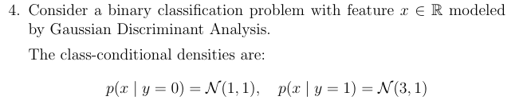
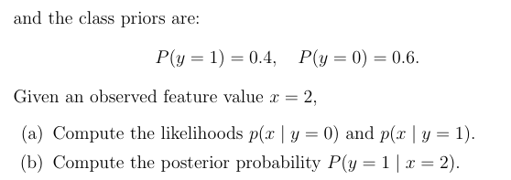

We are given:
$$p(x∣y=0)=N(1,1) \\ p(x∣y=1)=N(3,1)$$
Priors:
$$P(y=0)=0.6 \\ P(y=1)=0.4$$
Observed value:
$$x=2$$

(a) Compute the likelihoods
For a Gaussian distribution:
Here:
$$σ^{2}=1$$
so:
$$p(x)=\frac{1}{\sqrt{2π}}e^{-\frac{{\left(x-μ\right)}^{2}}{2}}$$

Likelihood for $y=0$
Mean:
$$μ_{0}=1$$
Substitute $x=2$:
$$p(x=2∣y=0)=\frac{1}{\sqrt{2π}}e^{-\frac{{\left(2-1\right)}^{2}}{2}} \\ =\frac{1}{\sqrt{2π}}e^{-1/2}$$
Using:
$$\frac{1}{\sqrt{2π}}≈0.399 \\ e^{-1/2}≈0.607 \\ p(x=2∣y=0)≈0.399×0.607 \\ \boxed{p(x∣y=0)≈0.242}$$

Likelihood for $y=1$
Mean:
$$μ_{1}=3 \\ p(x=2∣y=1)=\frac{1}{\sqrt{2π}}e^{-\frac{{\left(2-3\right)}^{2}}{2}}$$
Again:
$$\left(2-3)^{2}=1\right.$$
So we get the same value:
$$\boxed{p(x∣y=1)≈0.242}$$

(b) Compute posterior probability $P(y=1∣x=2)$
Using Bayes theorem:
Substitute values:
$$P(y=1∣x=2)=\frac{\left(0.242)(0.4\right)}{\left(0.242)(0.4)+(0.242)(0.6\right)}$$
Factor out $0.242$:
$$=\frac{0.4}{0.4+0.6} \\ =\frac{0.4}{1} \\ \boxed{P(y=1∣x=2)=0.4}$$

Final Answers
(a)
$$\boxed{p(x∣y=0)≈0.242} \\ \boxed{p(x∣y=1)≈0.242}$$
(b)
$$\boxed{P(y=1∣x=2)=0.4}$$

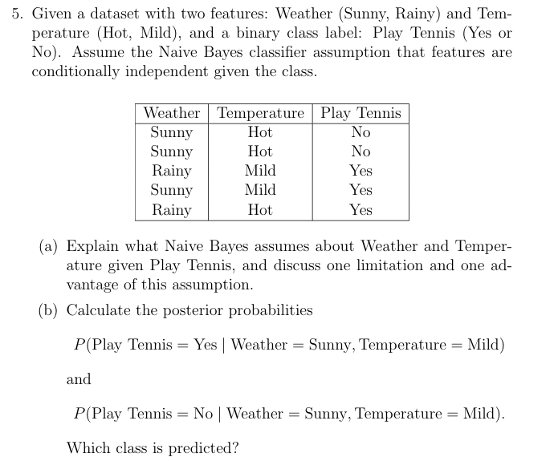
(a) Naive Bayes Assumption
Naive Bayes assumes that the features are conditionally independent given the class label.
For this problem:
- Features: Weather and Temperature
- Class label: Play Tennis
So the assumption is:
$$P(\text{Weather, Temperature}∣\text{Play Tennis})=P(\text{Weather}∣\text{Play Tennis})×P(\text{Temperature}∣\text{Play Tennis})$$
This means that once we know whether the person plays tennis or not, the features Weather and Temperature are treated as independent.
For example:
$$P(\text{Sunny and Mild}∣\text{Yes})=P(\text{Sunny}∣\text{Yes})×P(\text{Mild}∣\text{Yes})$$

Advantage
- Makes computation simple and fast.
- Works efficiently even on small datasets.

Limitation
- In reality, features may not truly be independent.
- For example, Weather and Temperature are often related.
So the assumption may sometimes reduce prediction accuracy.

Dataset
Weather | Temperature | Play Tennis
Sunny | Hot | No
Sunny | Hot | No
Rainy | Mild | Yes
Sunny | Mild | Yes
Rainy | Hot | Yes
Total samples = 5

(b) Calculate Posterior Probabilities
We need to calculate:
$$P(\text{Play Tennis = Yes}∣\text{Weather = Sunny, Temperature = Mild})$$
and
$$P(\text{Play Tennis = No}∣\text{Weather = Sunny, Temperature = Mild})$$
Using Naive Bayes:
$$P(C∣X)∝P(C) P(W∣C) P(T∣C)$$
where:
- $C$= class label
- $W$= Weather
- $T$= Temperature

Step 1: Prior Probabilities
For Yes
Number of Yes instances = 3
$$P(\text{Yes})=\frac{3}{5}$$
For No
Number of No instances = 2
$$P(\text{No})=\frac{2}{5}$$

Step 2: Conditional Probabilities
Given Play Tennis = Yes
Rows with Yes:
Weather | Temperature
Rainy | Mild
Sunny | Mild
Rainy | Hot
Probability of Sunny given Yes
Only 1 Sunny among 3 Yes rows:
$$P(\text{Sunny}∣\text{Yes})=\frac{1}{3}$$
Probability of Mild given Yes
2 Mild among 3 Yes rows:
$$P(\text{Mild}∣\text{Yes})=\frac{2}{3}$$

Given Play Tennis = No
Rows with No:
Weather | Temperature
Sunny | Hot
Sunny | Hot
Probability of Sunny given No
$$P(\text{Sunny}∣\text{No})=\frac{2}{2}=1$$
Probability of Mild given No
No Mild among No rows:
$$P(\text{Mild}∣\text{No})=\frac{0}{2}=0$$

Step 3: Compute Unnormalized Posterior Probabilities
For Yes
$$P(\text{Yes})P(\text{Sunny}∣\text{Yes})P(\text{Mild}∣\text{Yes}) \\ =\frac{3}{5}×\frac{1}{3}×\frac{2}{3}=\frac{2}{15}≈0.1333$$

For No
$$P(\text{No})P(\text{Sunny}∣\text{No})P(\text{Mild}∣\text{No}) \\ =\frac{2}{5}×1×0=0$$

Step 4: Normalize
Total:
$$\frac{2}{15}+0=\frac{2}{15}$$

Posterior Probability for Yes
$$P(\text{Yes}∣\text{Sunny, Mild})=\frac{2/15}{2/15}=1$$

Posterior Probability for No
$$P(\text{No}∣\text{Sunny, Mild})=\frac{0}{2/15}=0$$

Final Answers
$$\boxed{P(\text{Play Tennis = Yes}∣\text{Sunny, Mild})=1} \\ \boxed{P(\text{Play Tennis = No}∣\text{Sunny, Mild})=0}$$
Predicted Class
Since:
$$1>0$$
the predicted class is:
$$\boxed{\text{Play Tennis = Yes}}$$
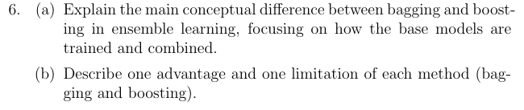
(a) Main Conceptual Difference Between Bagging and Boosting
Bagging (Bootstrap Aggregating)
In bagging, multiple models are trained:
- Independently
- In parallel
- Using different random subsets of the training data
The final prediction is usually obtained by:
- Majority voting (classification)
- Averaging (regression)
The main idea is to reduce variance.
Example: Random Forest

Boosting
In boosting, models are trained:
- Sequentially
- Each new model focuses more on the mistakes made by previous models
Predictions from all models are combined using a weighted sum/vote.
The main idea is to reduce bias and improve accuracy.
Example: AdaBoost, XGBoost

Simple Comparison
Feature | Bagging | Boosting
Training Style | Parallel | Sequential
Main Goal | Reduce variance | Reduce bias
Data Usage | Random bootstrap samples | Reweighted/focused on errors
Model Dependence | Independent models | Dependent models
Combination | Average / majority vote | Weighted combination
(b) Advantages and Limitations
Bagging
Advantage
- Reduces overfitting and variance.
- More stable and robust.
Example: Random Forest handles noisy data well.

Limitation
- Does not significantly reduce bias.
- If base models are weak, performance may still be limited.

Boosting
Advantage
- Often achieves very high prediction accuracy.
- Converts weak learners into a strong learner.

Limitation
- More sensitive to noise and outliers.
- Sequential training makes it slower and can lead to overfitting if not tuned properly.

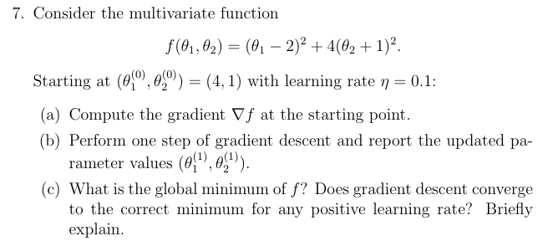
We are given the function:
Starting point:
$$\left(θ_{1}^{\left(0\right)},θ_{2}^{\left(0\right)})=(4,1\right)$$
Learning rate:
$$η=0.1$$

(a) Compute the Gradient
The gradient is:
$$∇f=\left(\frac{∂f}{∂θ_{1}} , \frac{∂f}{∂θ_{2}}\right)$$

Partial derivative with respect to $θ_{1}$
$$\frac{∂f}{∂θ_{1}}=2(θ_{1}-2)$$

Partial derivative with respect to $θ_{2}$
$$\frac{∂f}{∂θ_{2}}=8(θ_{2}+1)$$
So:
$$∇f=\left(2(θ_{1}-2),8(θ_{2}+1)\right)$$
Now substitute the starting point $\left(4 , 1\right)$:
$$∇f(4,1)=\left(2(4-2),8(1+1)\right) \\ =(4,16)$$
✅ Gradient at starting point:
$$\boxed{∇f(4,1)=(4,16)}$$

(b) One Step of Gradient Descent
Gradient descent update rule:
$$θ^{\left(1\right)}=θ^{\left(0\right)}-η∇f$$

Update $θ_{1}$
$$θ_{1}^{\left(1\right)}=4-0.1(4) \\ =4-0.4 \\ =3.6$$

Update $θ_{2}$
$$θ_{2}^{\left(1\right)}=1-0.1(16) \\ =1-1.6 \\ =-0.6$$

✅ Updated parameters:
$$\boxed{\left(θ_{1}^{\left(1\right)},θ_{2}^{\left(1\right)})=(3.6,-0.6\right)}$$

(c) Global Minimum and Convergence
The function is:
$$f(θ_{1},θ_{2})=(θ_{1}-2)^{2}+4(θ_{2}+1)^{2}$$
A squared term is minimized when it becomes zero.
So minimum occurs at:
$$θ_{1}-2=0⇒θ_{1}=2 \\ θ_{2}+1=0⇒θ_{2}=-1$$

Global Minimum Point
$$\boxed{\left(2,-1\right)}$$
Minimum value:
$$f(2,-1)=0 \\ \boxed{f_{min}=0}$$

Does Gradient Descent Converge for Any Positive Learning Rate?
❌ No.
Gradient descent does not converge for every positive learning rate.
- If the learning rate is too large, updates may overshoot the minimum.
- The algorithm may oscillate or diverge.
For this quadratic convex function, gradient descent converges only when the learning rate is sufficiently small.
✅ In general:
$$0<η<\frac{2}{L}$$
where $L$ is related to the largest curvature (largest eigenvalue of Hessian).

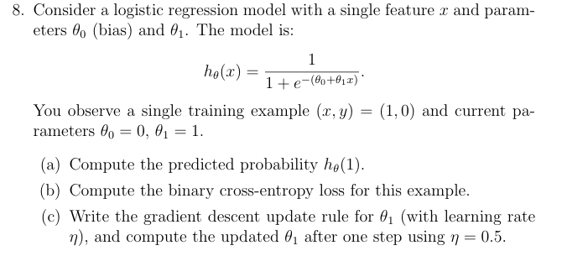

We are given the logistic regression model:
Training example:
$$\left(x,y)=(1,0\right)$$
Current parameters:
$$θ_{0}=0,θ_{1}=1$$
Learning rate:
$$η=0.5$$

(a) Compute the Predicted Probability $h_{θ}(1)$
Substitute values into the model:
$$h_{θ}(1)=\frac{1}{1+e^{-(0+1⋅1)}} \\ =\frac{1}{1+e^{-1}}$$
Using:
$$e^{-1}≈0.3679 \\ h_{θ}(1)=\frac{1}{1+0.3679} \\ =\frac{1}{1.3679} \\ ≈0.731$$
✅ Predicted probability:
$$\boxed{h_{θ}(1)≈0.731}$$

(b) Binary Cross-Entropy Loss
Loss function for one example:
$$L=-\left[ylog⁡(h_{θ}(x))+(1-y)log⁡(1-h_{θ}(x))\right]$$
Given:
$$y=0$$
So:
$$L=-log⁡(1-h_{θ}(x))$$
Substitute $h_{θ}(x)=0.731$:
$$L=-log⁡(1-0.731) \\ =-log⁡(0.269) \\ ≈1.313$$
✅ Binary cross-entropy loss:
$$\boxed{1.313}$$

(c) Gradient Descent Update for $θ_{1}$
For logistic regression:
$$\frac{∂L}{∂θ_{1}}=(h_{θ}(x)-y)x$$
Gradient descent update rule:
$$θ_{1}^{\text{new}}=θ_{1}-η(h_{θ}(x)-y)x$$
Now substitute values:
$$θ_{1}^{\text{new}}=1-0.5(0.731-0)(1) \\ =1-0.5(0.731) \\ =1-0.3655 \\ ≈0.6345$$
✅ Updated parameter:
$$\boxed{θ_{1}^{\text{new}}≈0.635}$$

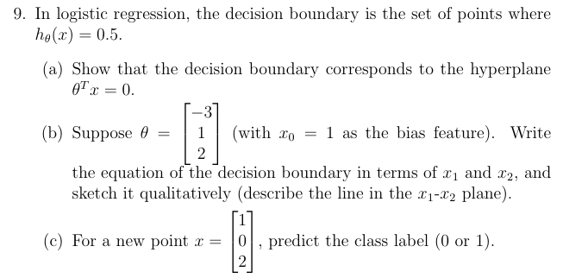
We know that logistic regression predicts:
$$h_{θ}(x)=\frac{1}{1+e^{-θ^{T}x}}$$
The decision boundary occurs where:
$$h_{θ}(x)=0.5$$

(a) Show that the Decision Boundary is $θ^{T}x=0$
Set:
$$\frac{1}{1+e^{-θ^{T}x}}=0.5$$
Multiply both sides:
$$1=0.5(1+e^{-θ^{T}x}) \\ 2=1+e^{-θ^{T}x} \\ 1=e^{-θ^{T}x}$$
Take natural log:
$$ln⁡(1)=-θ^{T}x$$
Since:
$$ln⁡(1)=0$$
we get:
$$\boxed{θ^{T}x=0}$$
✅ Hence, the decision boundary is a hyperplane.

(b) Equation of the Decision Boundary
Given:
$$θ=\left[\begin{aligned}-3 \\ 1 \\ 2\end{aligned}\right]$$
with bias feature:
$$x_{0}=1$$
The decision boundary is:
$$θ^{T}x=0$$
Expanding:
$$-3(1)+1x_{1}+2x_{2}=0 \\ -3+x_{1}+2x_{2}=0$$
So:
$$\boxed{x_{1}+2x_{2}=3}$$
or equivalently:
$$\boxed{x_{2}=\frac{3-x_{1}}{2}}$$

Qualitative Sketch
This is a straight line in the $x_{1}-x_{2}$plane.
Key properties
- Slope:
$$-\frac{1}{2}$$
- $x_{2}$-intercept:
$$\frac{3}{2}=1.5$$
- $x_{1}$-intercept:
$$3$$
So the line:
- passes through $\left(3 , 0\right)$
- passes through $\left(0 , 1.5\right)$
- slopes downward from left to right

(c) Predict the Class for
$$x=\left[\begin{aligned}1 \\ 0 \\ 2\end{aligned}\right]$$
Compute:
$$θ^{T}x=(-3)(1)+(1)(0)+(2)(2) \\ =-3+0+4 \\ =1$$
Since:
$$θ^{T}x>0$$
the sigmoid output is greater than $0.5$.
Therefore the predicted label is:
$$\boxed{1}$$
✅ Predicted class:
$$\boxed{\text{Class }1}$$
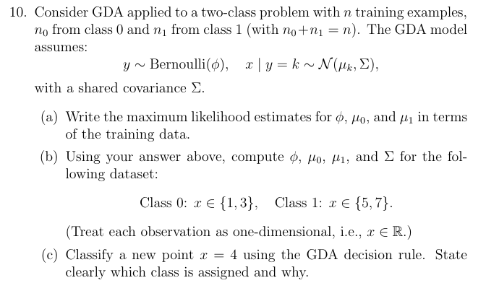

We are given the Gaussian Discriminant Analysis (GDA) model:
$$y∼\text{Bernoulli}(ϕ) \\ x∣y=k∼N(μ_{k},Σ)$$
with shared covariance matrix $Σ$.

(a) Maximum Likelihood Estimates
Suppose:
- $n$= total training examples
- $n_{0}$= number of class 0 examples
- $n_{1}$= number of class 1 examples
with:
$$n=n_{0}+n_{1}$$

Estimate of $ϕ$
$$\boxed{ϕ=\frac{n_{1}}{n}}$$
This is the fraction of examples belonging to class 1.

Estimate of $μ_{0}$
$$\boxed{μ_{0}=\frac{1}{n_{0}}\sum_{i:y^{\left(i\right)}=0}{x^{\left(i\right)}}}$$
Mean of class 0 points.

Estimate of $μ_{1}$
$$\boxed{μ_{1}=\frac{1}{n_{1}}\sum_{i:y^{\left(i\right)}=1}{x^{\left(i\right)}}}$$
Mean of class 1 points.

Estimate of Shared Covariance
$$\boxed{Σ=\frac{1}{n}\sum_{i=1}^{n}{(}x^{\left(i\right)}-μ_{y^{\left(i\right)}})^{2}}$$
(For 1D data this becomes variance.)

(b) Compute $ϕ,μ_{0},μ_{1},Σ$
Dataset:
Class 0
$$x∈\{1,3\}$$
Class 1
$$x∈\{5,7\}$$
Total examples:
$$n=4$$
Number in each class:
$$n_{0}=2,n_{1}=2$$

Step 1: Compute $ϕ$
$$ϕ=\frac{n_{1}}{n}=\frac{2}{4} \\ \boxed{ϕ=0.5}$$

Step 2: Compute $μ_{0}$
$$μ_{0}=\frac{1+3}{2} \\ =\frac{4}{2} \\ \boxed{μ_{0}=2}$$

Step 3: Compute $μ_{1}$
$$μ_{1}=\frac{5+7}{2} \\ =\frac{12}{2} \\ \boxed{μ_{1}=6}$$

Step 4: Compute Shared Covariance $Σ$
For each point compute:
$${\left(x-μ_{y}\right)}^{2}$$

Class 0
For $x=1$:
$$\left(1-2)^{2}=1\right.$$
For $x=3$:
$$\left(3-2)^{2}=1\right.$$

Class 1
For $x=5$:
$$\left(5-6)^{2}=1\right.$$
For $x=7$:
$$\left(7-6)^{2}=1\right.$$

Total:
$$1+1+1+1=4$$
Now divide by $n=4$:
$$Σ=\frac{4}{4} \\ \boxed{Σ=1}$$

(c) Classify $x=4$
We compare which Gaussian likelihood is larger.
Since:
- Shared covariance is equal
- Priors are equal ($ϕ=0.5$)
classification depends on which mean is closer to $x=4$.

Distance to class 0 mean:
$$∣4-2∣=2$$
Distance to class 1 mean:
$$∣4-6∣=2$$
The distances are equal.
So:
$$p(x∣y=0)=p(x∣y=1)$$
and priors are also equal.

Final Decision
Both classes are equally likely.
$$\boxed{\text{Tie between class 0 and class 1}}$$
A practical implementation may:
- choose either class,
- or use a default tie-breaking rule.

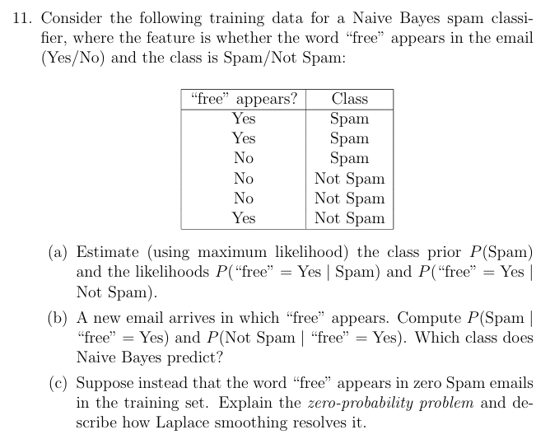

Total emails:$6$
(a) Estimate Priors and Likelihoods

Step 1: Compute Class Prior $P(\text{Spam})$
Number of Spam emails:
$$3$$
Total emails:
$$6$$
So:
$$P(\text{Spam})=\frac{3}{6} \\ \boxed{P(\text{Spam})=0.5}$$
Similarly:
$$P(\text{Not Spam})=0.5$$

Step 2: Compute Likelihoods
$$P(\text{“free”=Yes}∣\text{Spam})$$
Among Spam emails:
“free” appears?
Yes
Yes
No
Number with Yes:
$$2$$
Total Spam emails:
$$3$$
Therefore:
$$P(\text{Yes}∣\text{Spam})=\frac{2}{3} \\ \boxed{P(\text{“free”=Yes}∣\text{Spam})=\frac{2}{3}}$$

$$P(\text{“free”=Yes}∣\text{Not Spam})$$
Among Not Spam emails:
“free” appears?
No
No
Yes
Number with Yes:
$$1$$
Total Not Spam emails:
$$3$$
Thus:
$$P(\text{Yes}∣\text{Not Spam})=\frac{1}{3} \\ \boxed{P(\text{“free”=Yes}∣\text{Not Spam})=\frac{1}{3}}$$

(b) Compute Posterior Probabilities
We need:
$$P(\text{Spam}∣\text{Yes})$$
and
$$P(\text{Not Spam}∣\text{Yes})$$
Using Naive Bayes:

Step 1: Compute Unnormalized Probabilities
Spam
$$P(\text{Yes}∣\text{Spam})P(\text{Spam}) \\ =\frac{2}{3}×0.5 \\ =\frac{1}{3}$$

Not Spam
$$P(\text{Yes}∣\text{Not Spam})P(\text{Not Spam}) \\ =\frac{1}{3}×0.5 \\ =\frac{1}{6}$$

Step 2: Normalize
Total:
$$\frac{1}{3}+\frac{1}{6}=\frac{1}{2}$$

Posterior for Spam
$$P(\text{Spam}∣\text{Yes})=\frac{1/3}{1/2}=\frac{2}{3} \\ \boxed{P(\text{Spam}∣\text{“free”=Yes})=\frac{2}{3}}$$

Posterior for Not Spam
$$P(\text{Not Spam}∣\text{Yes})=\frac{1/6}{1/2}=\frac{1}{3} \\ \boxed{P(\text{Not Spam}∣\text{“free”=Yes})=\frac{1}{3}}$$

Predicted Class
Since:
$$\frac{2}{3}>\frac{1}{3}$$
Naive Bayes predicts:
$$\boxed{\text{Spam}}$$

(c) Zero-Probability Problem and Laplace Smoothing
Suppose the word “free” appeared in zero Spam emails.
Then:
$$P(\text{“free”=Yes}∣\text{Spam})=0$$
In Naive Bayes, probabilities are multiplied together.
So even if other features strongly indicate Spam:
$$P(\text{Spam}∣X)=0$$
This is called the zero-probability problem.

Laplace Smoothing
Laplace smoothing avoids zero probabilities by adding 1 to each count.
Instead of:
$$P(X=v∣C)=\frac{\text{count}}{\text{total}}$$
we use:
$$P(X=v∣C)=\frac{\text{count}+1}{\text{total}+k}$$
where:
- $k$= number of possible feature values.
For “Yes/No”:
$$k=2$$
This ensures every probability is nonzero and improves generalization.

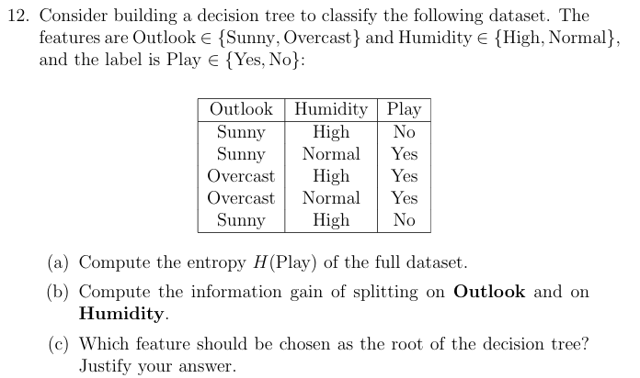

Total samples:$5$
Class counts:
- Yes = 3
- No = 2

(a) Compute Entropy $H(\text{Play})$
Entropy formula:
$$H(Y)=-∑p_{i}{log⁡}_{2}p_{i}$$

Step 1: Probabilities
$$P(\text{Yes})=\frac{3}{5}=0.6 \\ P(\text{No})=\frac{2}{5}=0.4$$

Step 2: Plug into entropy formula
$$H(\text{Play})=-(0.6){log⁡}_{2}(0.6)-(0.4){log⁡}_{2}(0.4)$$
Using:
$${log⁡}_{2}(0.6)≈-0.737 \\ {log⁡}_{2}(0.4)≈-1.322$$
So:
$$H=-(0.6)(-0.737)-(0.4)(-1.322) \\ =0.442+0.529 \\ \boxed{H(\text{Play})≈0.971}$$

(b) Compute Information Gain
Formula:
$$IG=H(\text{parent})-\text{weighted child entropy}$$

Split on Outlook
1. Outlook = Sunny
Rows:
Humidity | Play
High | No
Normal | Yes
High | No
Counts:
- Yes = 1
- No = 2
Entropy:
$$H=-\frac{1}{3}{log⁡}_{2}\frac{1}{3}-\frac{2}{3}{log⁡}_{2}\frac{2}{3} \\ ≈0.918$$

2. Outlook = Overcast
Rows:
Humidity | Play
High | Yes
Normal | Yes
All are Yes, so:
$$H=0$$

Weighted entropy
$$\frac{3}{5}(0.918)+\frac{2}{5}(0) \\ =0.551$$

Information Gain
$$IG(\text{Outlook})=0.971-0.551 \\ \boxed{IG(\text{Outlook})=0.420}$$

Split on Humidity

Humidity = High
Rows:
Outlook | Play
Sunny | No
Overcast | Yes
Sunny | No
Counts:
- Yes = 1
- No = 2
Entropy:
$$0.918$$

Humidity = Normal
Rows:
Outlook | Play
Sunny | Yes
Overcast | Yes
All Yes:
$$H=0$$

Weighted entropy
$$\frac{3}{5}(0.918)+\frac{2}{5}(0) \\ =0.551$$

Information Gain
$$IG(\text{Humidity})=0.971-0.551 \\ \boxed{IG(\text{Humidity})=0.420}$$

(c) Choose Root Feature
Both features have the same information gain:
$$IG(\text{Outlook})=IG(\text{Humidity})=0.420$$
So either feature can be chosen.
$$\boxed{\text{Either Outlook or Humidity can be chosen as root}}$$
Justification
Both reduce uncertainty by the same amount, so the decision tree algorithm has no preference based on information gain alone.

Final Answers
(a)
$$\boxed{H(\text{Play})≈0.971}$$

(b)
$$\boxed{IG(\text{Outlook})=0.420} \\ \boxed{IG(\text{Humidity})=0.420}$$

(c)
$$\boxed{\text{Either Outlook or Humidity}}$$
because both give equal information gain.
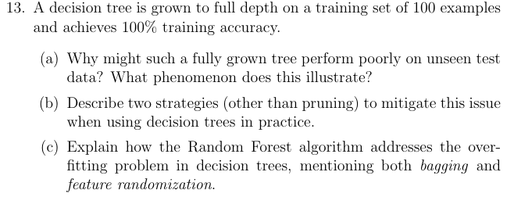
(a) Why a Fully Grown Tree May Perform Poorly on Test Data
A fully grown decision tree can memorize the training data instead of learning general patterns.
So although it achieves:
$$100\%\text{ training accuracy}$$
it may fail on unseen data because it has learned:
- noise,
- outliers,
- random fluctuations
from the training set.
This phenomenon is called:
$$\boxed{\text{Overfitting}}$$

Why Overfitting Happens
Deep trees create many highly specific splits.
These splits may work perfectly for training examples but do not generalize well to new data.
So:
- Training error → very low
- Test error → high

(b) Two Strategies to Reduce Overfitting (Other Than Pruning)
1. Limit Tree Depth
Restrict the maximum depth of the tree.
Example:
- max depth = 3 or 5
This prevents the tree from becoming too complex.
Benefit
- Simpler model
- Better generalization

2. Require Minimum Samples per Split or Leaf
Set constraints such as:
- minimum samples required to split a node
- minimum samples allowed in a leaf
Example:
- min samples split = 10
- min samples leaf = 5
This avoids creating tiny leaves that memorize specific examples.
Benefit
- Reduces sensitivity to noise
- Produces smoother decision boundaries

(c) How Random Forest Reduces Overfitting
Random Forest reduces overfitting by combining many decision trees instead of relying on a single tree.
It uses two key ideas:

1. Bagging (Bootstrap Aggregating)
Each tree is trained on a different random bootstrap sample of the training data.
A bootstrap sample is created by:
- randomly sampling training examples
- with replacement
So every tree sees slightly different data.
Effect
- Trees become diverse
- Variance decreases
- Overfitting is reduced
Final prediction is made using:
- majority voting (classification)
- averaging (regression)

2. Feature Randomization
At each split, Random Forest considers only a random subset of features instead of all features.
Effect
- Trees become less correlated
- Prevents one strong feature from dominating all trees
- Increases diversity among trees

Overall Benefit
Combining:
- bagging
- feature randomness
makes Random Forest:
- more robust,
- less prone to overfitting,
- and better at generalization than a single decision tree.

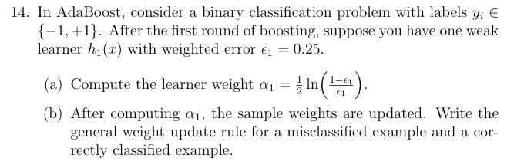
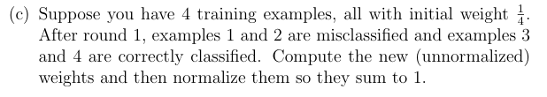
We are given:
- Weighted error:
$$ϵ_{1}=0.25$$
- AdaBoost learner weight formula:
$$α_{1}=\frac{1}{2}ln⁡\left(\frac{1-ϵ_{1}}{ϵ_{1}}\right)$$

(a) Compute $α_{1}$
Substitute:
$$α_{1}=\frac{1}{2}ln⁡\left(\frac{1-0.25}{0.25}\right) \\ =\frac{1}{2}ln⁡\left(\frac{0.75}{0.25}\right) \\ =\frac{1}{2}ln⁡(3)$$
Using:
$$ln⁡(3)≈1.099 \\ α_{1}=\frac{1}{2}(1.099) \\ \boxed{α_{1}≈0.549}$$

(b) Weight Update Rule
AdaBoost updates weights using:
$$w_{i}^{new}=w_{i}e^{-α_{t}y_{i}h_{t}(x_{i})}$$

For Correctly Classified Examples
If prediction is correct:
$$y_{i}h_{t}(x_{i})=+1$$
then:
$$w_{i}^{new}=w_{i}e^{-α_{t}}$$
✅ Weight decreases.

For Misclassified Examples
If prediction is wrong:
$$y_{i}h_{t}(x_{i})=-1$$
then:
$$w_{i}^{new}=w_{i}e^{+α_{t}}$$
✅ Weight increases.

(c) Compute New Weights
Initial weights:
$$w_{i}=\frac{1}{4}=0.25$$
Examples:
- 1 and 2 → misclassified
- 3 and 4 → correctly classified
We already computed:
$$α_{1}≈0.549$$
Also:
$$e^{0.549}≈1.732 \\ e^{-0.549}≈0.577$$

Step 1: Unnormalized Weights
Misclassified examples (1 and 2)
$$w^{'}=0.25(1.732) \\ =0.433$$
So:
$$w_{1}^{'}=w_{2}^{'}=0.433$$

Correctly classified examples (3 and 4)
$$w^{'}=0.25(0.577) \\ =0.144$$
So:
$$w_{3}^{'}=w_{4}^{'}=0.144$$

Step 2: Compute Total
$$0.433+0.433+0.144+0.144 \\ =1.154$$

Step 3: Normalize
Example 1
$$w_{1}=\frac{0.433}{1.154}≈0.375$$
Same for example 2:
$$w_{2}≈0.375$$

Example 3
$$w_{3}=\frac{0.144}{1.154}≈0.125$$
Same for example 4:
$$w_{4}≈0.125$$

Final Normalized Weights
$$\boxed{\left(w_{1},w_{2},w_{3},w_{4})=(0.375,0.375,0.125,0.125\right)}$$

Final Answers
(a)
$$\boxed{α_{1}≈0.549}$$

(b)
Misclassified:
$$\boxed{w_{i}^{new}=w_{i}e^{+α_{t}}}$$
Correctly classified:
$$\boxed{w_{i}^{new}=w_{i}e^{-α_{t}}}$$

(c)
Unnormalized weights
$$\left(0.433 , 0.433 , 0.144 , 0.144\right)$$
Normalized weights
$$\boxed{\left(0.375 , 0.375 , 0.125 , 0.125\right)}$$
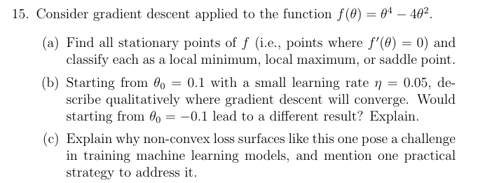
We are given:

(a) Find and Classify Stationary Points
Stationary points occur where:
$$f^{'}(θ)=0$$

Step 1: Compute First Derivative
$$f(θ)=θ^{4}-4θ^{2}$$
Differentiate:
$$f^{'}(θ)=4θ^{3}-8θ$$
Factor:
$$f^{'}(θ)=4θ(θ^{2}-2)$$
Set equal to zero:
$$4θ(θ^{2}-2)=0$$
So stationary points are:
$$θ=0$$
and
$$θ^{2}=2⇒θ=±\sqrt{2}$$

Step 2: Use Second Derivative Test
Second derivative:
$$f^{''}(θ)=12θ^{2}-8$$

At $θ=0$
$$f^{''}(0)=-8<0$$
So:
$$\boxed{θ=0\text{ is a local maximum}}$$

At $θ=\sqrt{2}$
$$f^{''}(\sqrt{2})=12(2)-8=16>0$$
So:
$$\boxed{θ=\sqrt{2}\text{ is a local minimum}}$$

At $θ=-\sqrt{2}$
$$f^{''}(-\sqrt{2})=16>0$$
So:
$$\boxed{θ=-\sqrt{2}\text{ is a local minimum}}$$

Final stationary points
Point | Type
(\theta=0) | Local maximum
(\theta=\sqrt2) | Local minimum
(\theta=-\sqrt2) | Local minimum
(b) Gradient Descent Behavior
Gradient descent update:
$$θ_{t+1}=θ_{t}-ηf^{'}(θ_{t})$$
with:
$$η=0.05$$

Starting from $θ_{0}=0.1$
Since $0.1>0$:
$$f^{'}(0.1)=4(0.1)^{3}-8(0.1) \\ =0.004-0.8 \\ =-0.796$$
The gradient is negative.
Gradient descent subtracts the gradient:
$$θ_{new}=θ-(-)=θ+\text{positive}$$
So $θ$increases toward the positive minimum.
Therefore:
$$\boxed{θ→\sqrt{2}}$$

Starting from $θ_{0}=-0.1$
Now the gradient becomes positive, so updates move left.
Thus:
$$\boxed{θ→-\sqrt{2}}$$

Conclusion
Yes, different starting points lead to different minima.
This happens because the function is non-convex and has multiple local minima.

(c) Why Non-Convex Loss Surfaces Are Challenging
Non-convex functions contain:
- multiple local minima,
- local maxima,
- flat regions,
- saddle points.
As a result:
- gradient descent may converge to different solutions depending on initialization,
- optimization can get stuck in poor local minima or saddle points.
This makes training harder and less predictable.

One Practical Strategy
Random Initialization + Multiple Runs
Train the model multiple times with different random initializations.
This increases the chance of finding a better minimum.
Other common strategies include:
- momentum,
- Adam optimizer,
- learning rate scheduling,
- stochastic gradient descent.

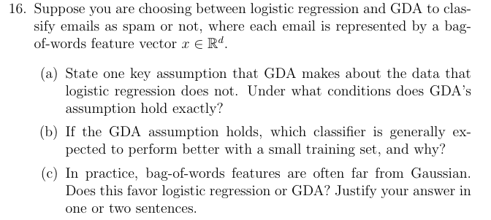
(a) Key Assumption of GDA
Gaussian Discriminant Analysis assumes that the feature vectors for each class are generated from a Gaussian (normal) distribution.
Specifically:
$$x∣y=k∼N(μ_{k},Σ)$$
with class-specific means and usually shared covariance.

Logistic Regression Difference
Logistic Regression does not assume any probability distribution for the input features $x$.
It directly models:
$$P(y∣x)$$
instead of modeling how the data is generated.

When Does GDA’s Assumption Hold Exactly?
The assumption holds exactly when:
- feature vectors within each class truly follow a multivariate Gaussian distribution,
- and the covariance structure matches the model assumption (e.g., shared covariance).

(b) Which Performs Better with Small Training Data?
If the GDA assumptions are correct, then:
$$\boxed{\text{GDA generally performs better with small datasets}}$$

Why?
Because GDA is a generative model:
- it models the full data distribution,
- so it can learn efficiently from fewer examples.
Logistic regression is discriminative and usually needs more data to estimate the decision boundary accurately.

(c) Bag-of-Words Features Are Not Gaussian
Bag-of-words features are typically:
- sparse,
- discrete,
- skewed,
- non-Gaussian.
This favors:
$$\boxed{\text{Logistic Regression}}$$
because logistic regression does not rely on the Gaussian assumption, whereas GDA can perform poorly when its distributional assumptions are violated.

